Setting Up Text-to-Speech for ITpipes – Windows Recording Device

1: The Windows audio recording device configuration window should have been opened by the ITpipes configuration utility when these instructions were opened.

2: Right-click below the last device in the list and select “Show Disabled Devices”:
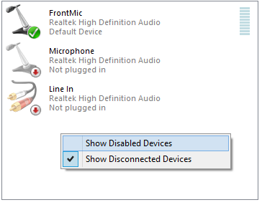

----------------------If “Stereo Mix” appears as an option in the list of recording devices---------------
3: If “Stereo Mix” appears in the list, right-click on it and select “Enable”:
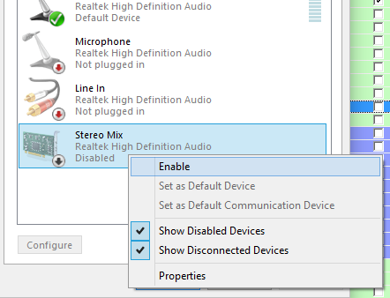

4: Once Stereo Mix is enabled, make sure it has a green circle with a checkmark on it—this means that it is the default recording device. If it does not have a green circle with a checkmark on it, this means that it is not the device which Windows will use to record audio. To fix this, right click on Stereo Mix and select “Set as Default Device”.

5: Test in ITpipes to verify that text-to-speech records onto video files properly.

-----If “Stereo Mix” DOES NOT appear as an option in the list of recording devices-----

Before proceeding, be sure that you close the Windows audio recording device configuration window! If you do not, you may have to restart the computer after installing the virtual audio cable!

3: Download a third-party virtual audio cable program. These instructions are for our preferred virtual audio cable, which can be downloaded from the developer's website:
http://vb-audio.pagesperso-orange.fr/Cable/index.htm

4: Unzip the contents of “Virtual Audio Recording Device.zip” to a folder, and right-click on “VBCABLE_Setup.exe”, choose “Run as Administrator”. If nothing happens, right-click on "VBCABLE_Setup_x64.exe” and choose "Run as Administrator". When the installer loads, press the “Install Driver” button and choose to install the driver if/when prompted by Windows (you do not need to restart Windows after installing the virtual audio cable):
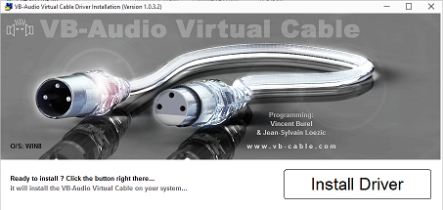

5: Reopen the list of audio recording devices, and you will see a new device in this list named “Cable Output VB-Audio Virtual Cable”. Right-click on this and set it as the default recording device:
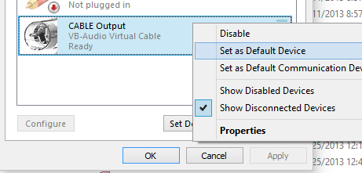

6: Right-click on the virtual cable device again and select “Properties”. Go to the “listen” tab in the window this opened and check the button labeled “Listen to this device”. Then open the dropdown right below that labeled “Playback through this device” and select your hardware speaker device (this should be your current default playback device--the current default playback device can be found by switching to the "Playback" tab and locating the name of the device with a checkmark on its icon). You may now press the “OK” button to close this window:
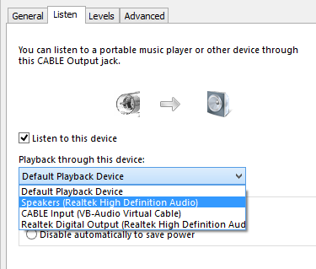

7: Select the “Playback” tab at the top of the Sound configuration utility. You will have a new device in this list named “Cable Input VB-Audio Virtual Cable”. Right-click on this device and set it as the default device, then right-click on it again and open the properties:
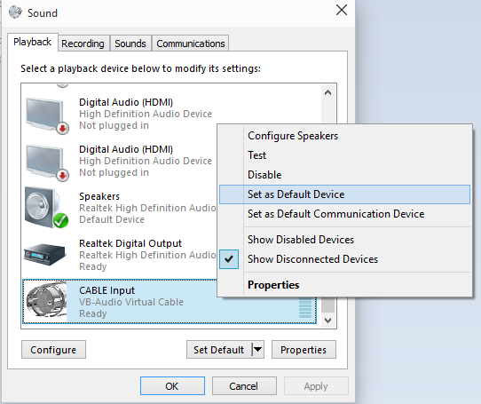

8: Go to the “Levels” tab on the properties window and make sure that the “CABLE Input” volume is at 100, and the icon next to it does not have a red circle with a slash through it (which would indicate that the device is muted). Once the settings look like the example below, press the “OK” button and close the Sound configuration window:

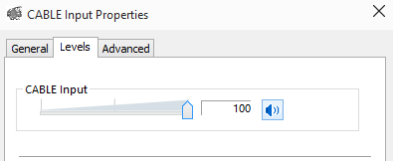

9: Test in ITpipes to verify that text-to-speech records onto video files properly.

